**Student FIRST Registration**

**You will need**: Your Email Address and Phone Number, Parents’ Email Address and Phone Number, and Home Address

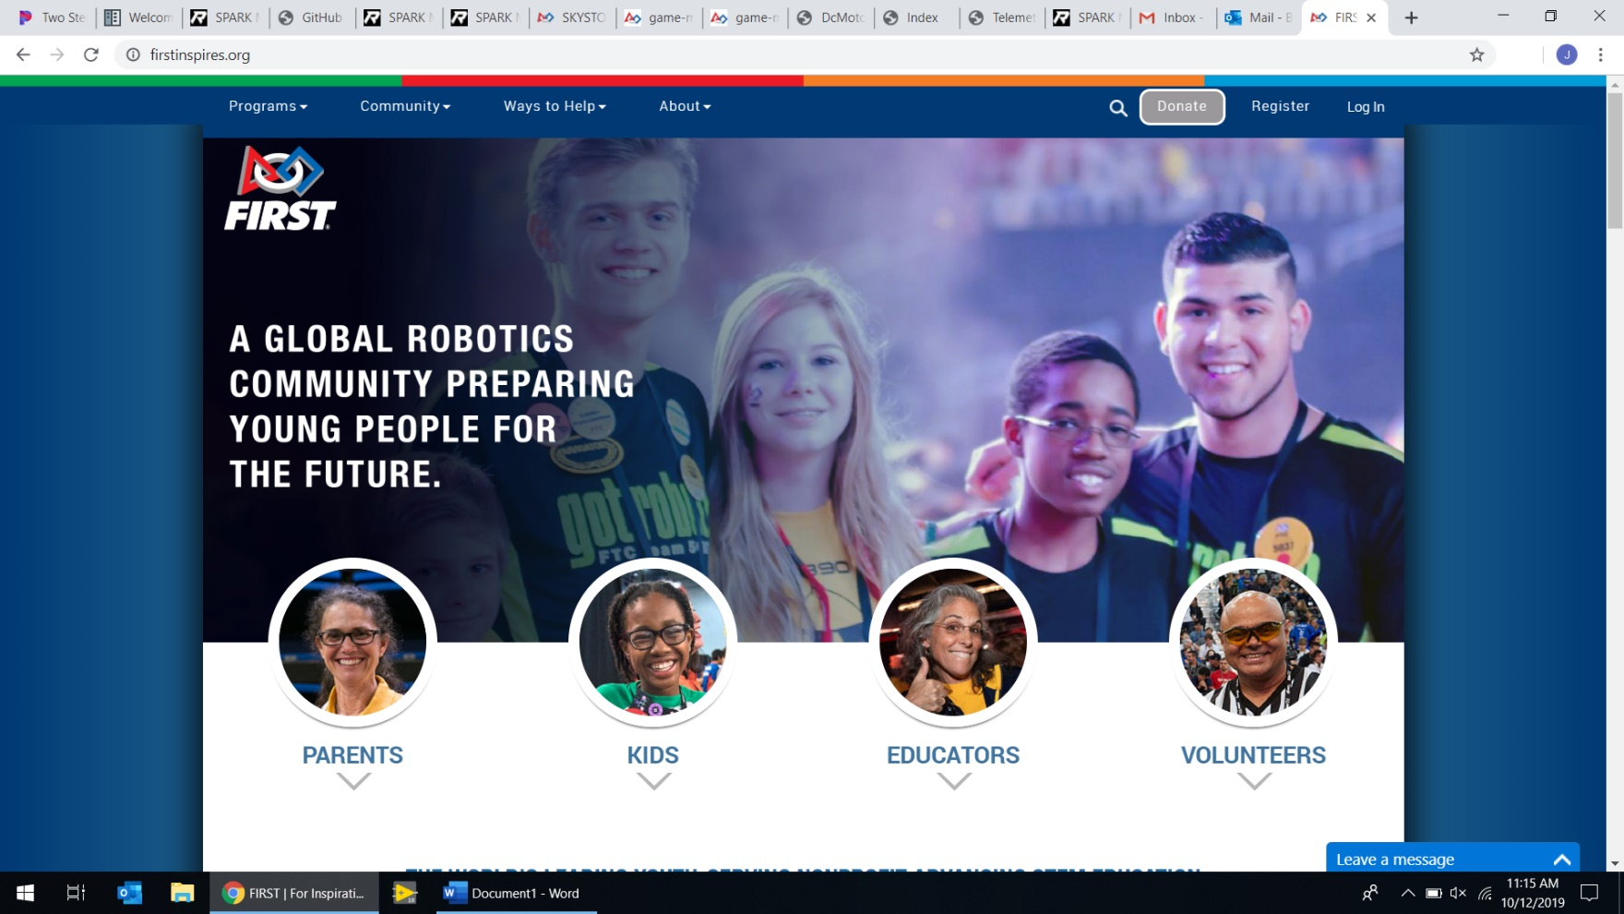

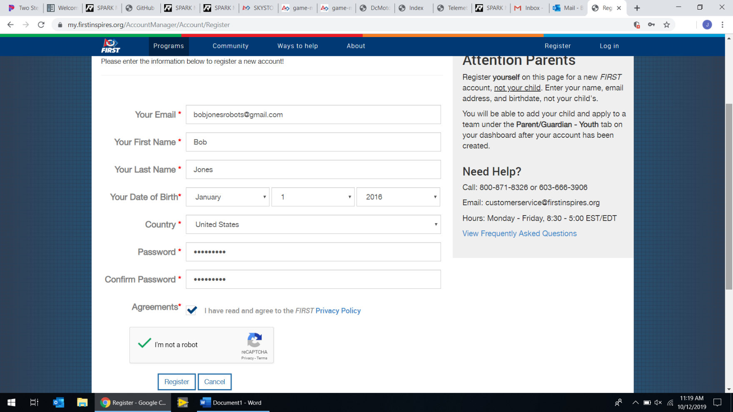

Go to [www.firstinspires.org](http://www.firstinspires.org) and click “Register” in the top right.

**1**

Fill in your information and click “Register”. Don’t forget to check the “I’m not a robot” box.

**2**

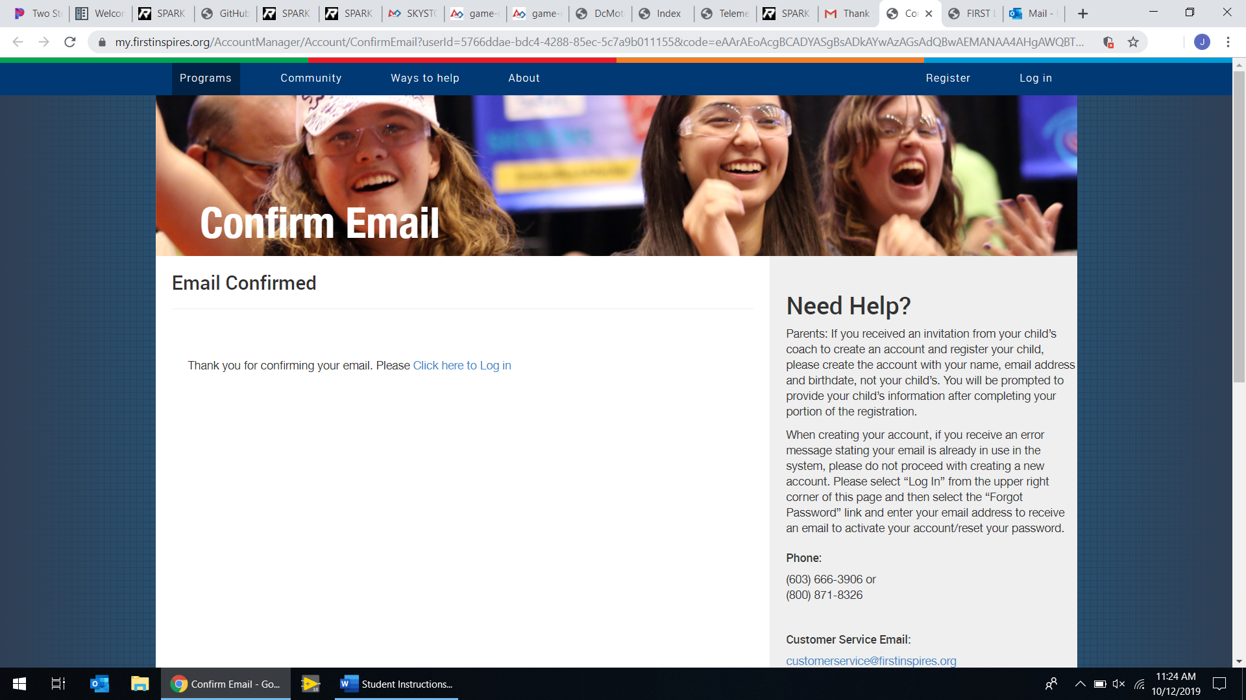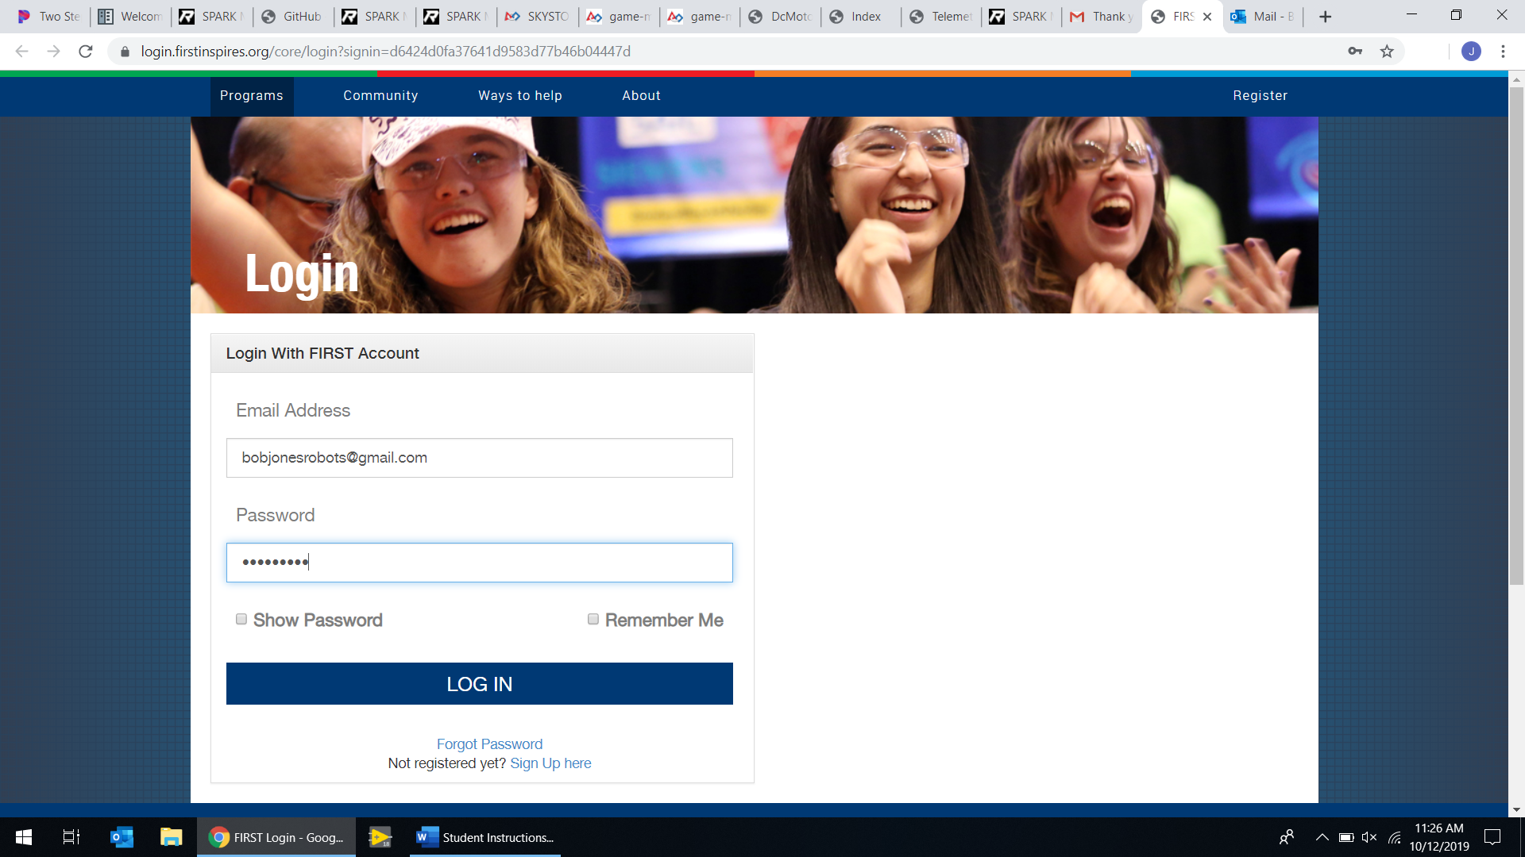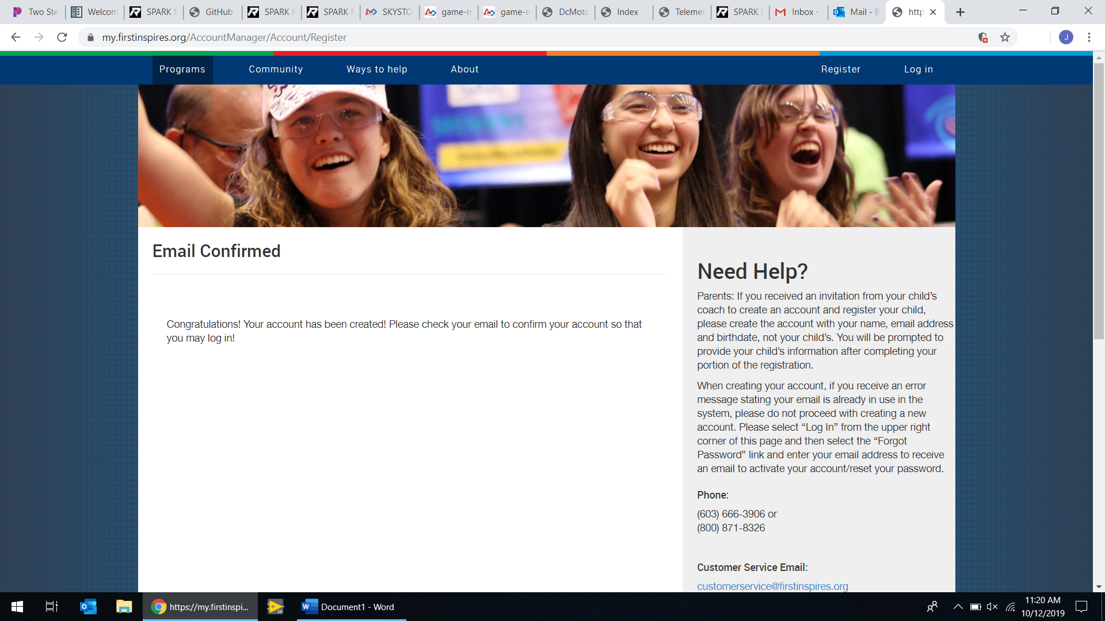

Log in to your account

**4**

Go to your email, find and open the email welcoming you to the FIRST community, and click the link in it to activate your account.

**3**

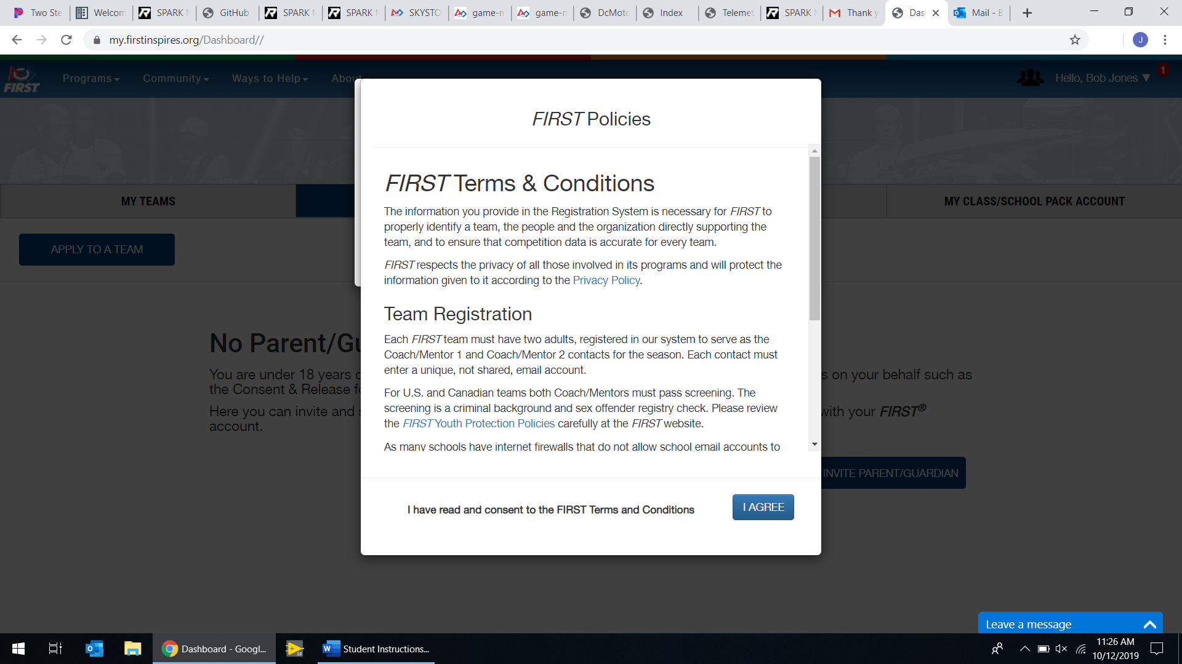

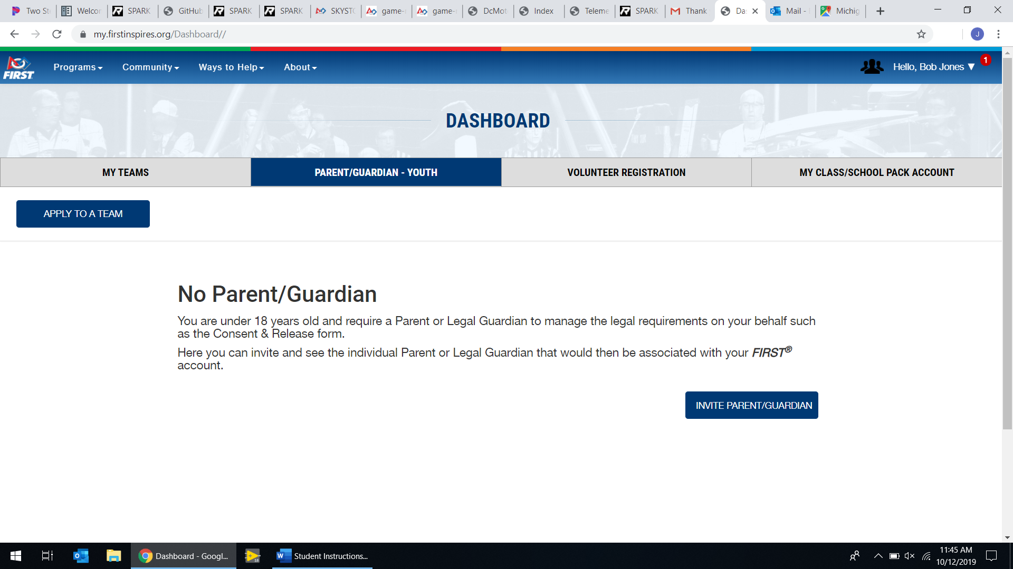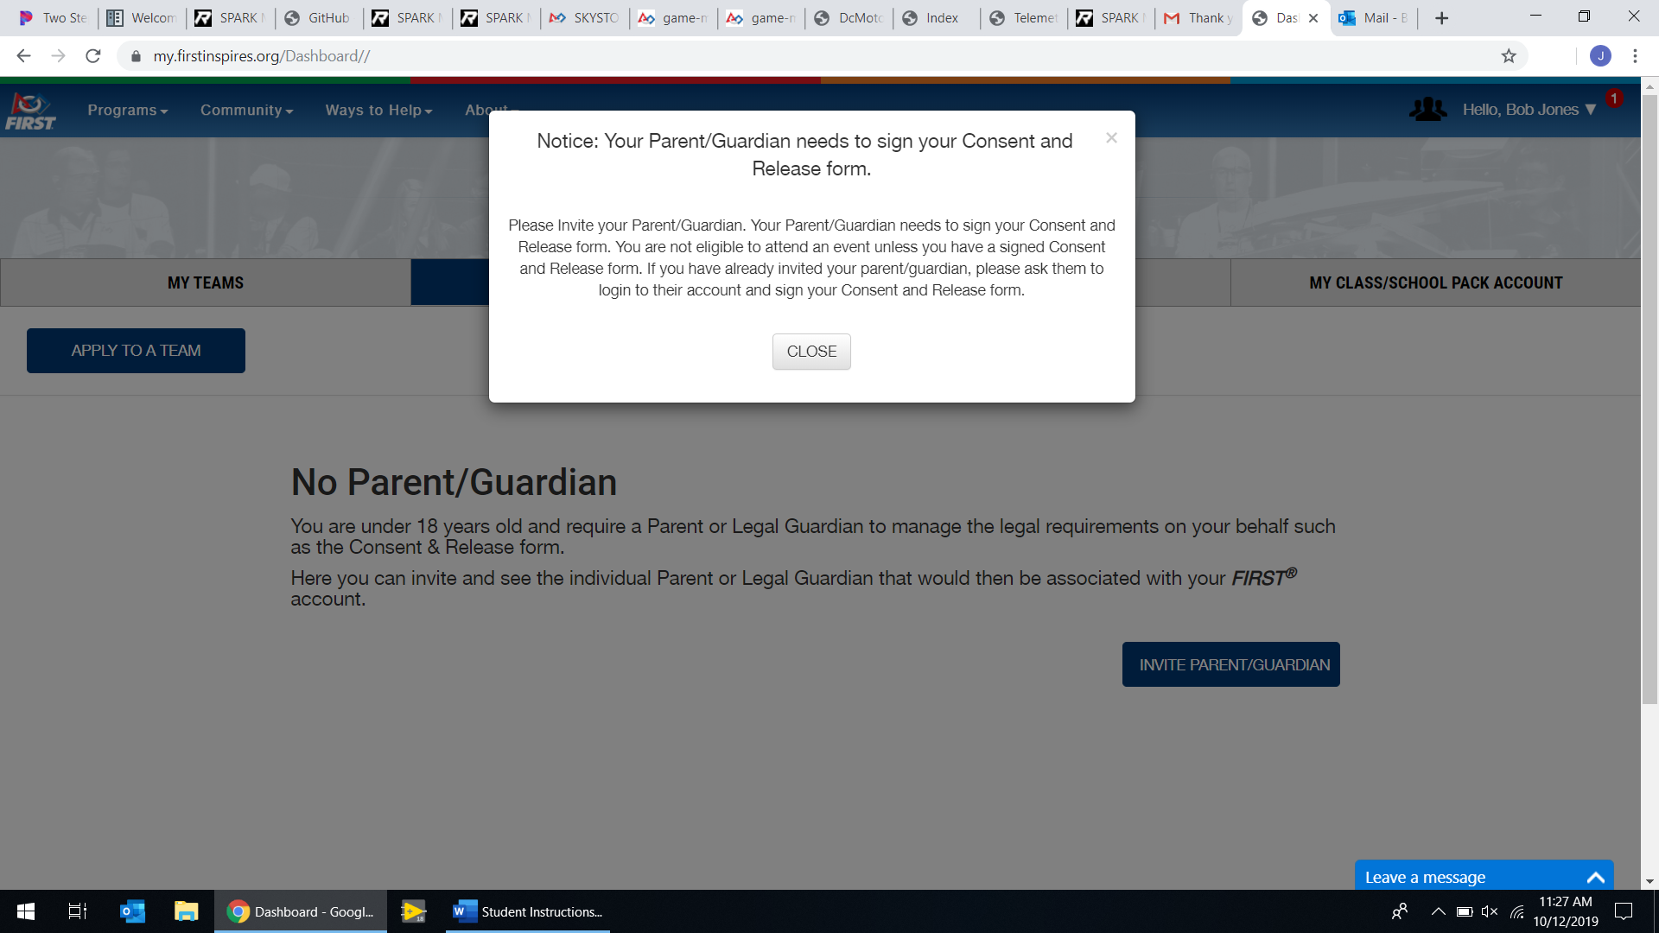

Click “Invite Parent/Guardian”.

**6**

Once signed in, a series of pop ups will come up; click “I Agree” on all of them. The last one (picture on the right) reminds you that your Parent/Guardian needs to sign your Consent and Release form.

**5**

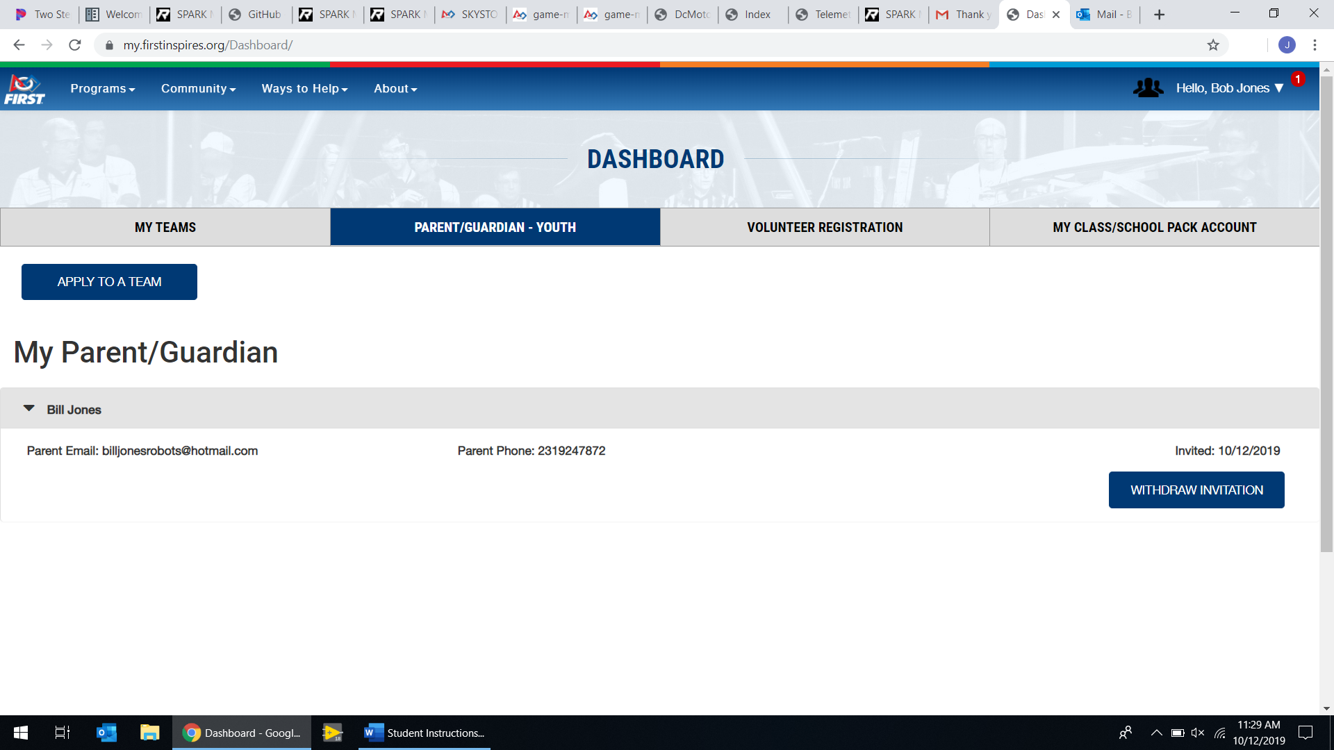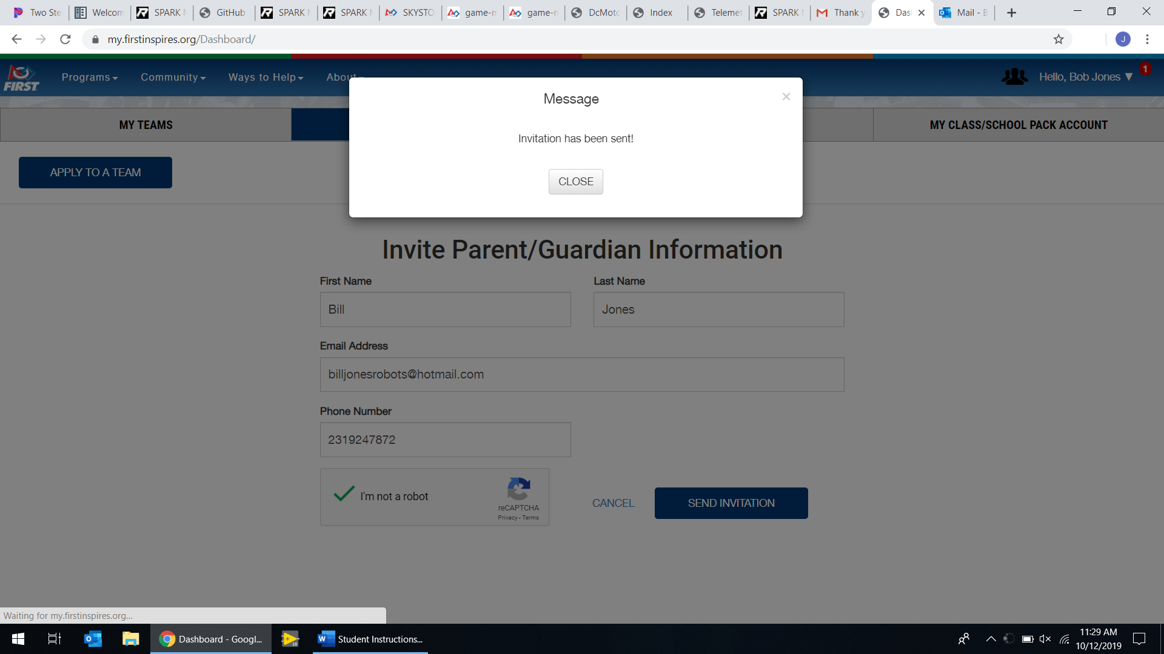

It will return you to the Dashboard. Click “Apply to a Team”.

**8**

Fill in your parent/guardian’s information, check the “I’m not a robot” box, and then click “Send Invitation”. You’ll get a message like the one above.

**7**

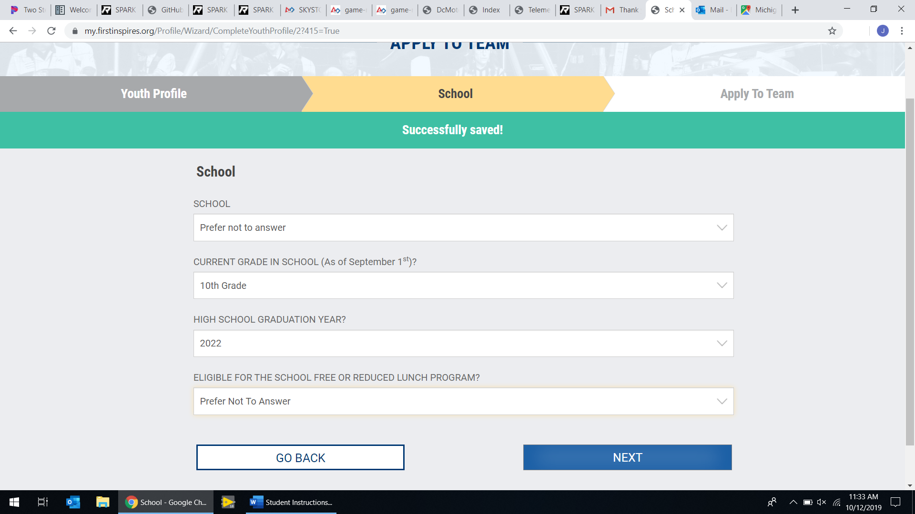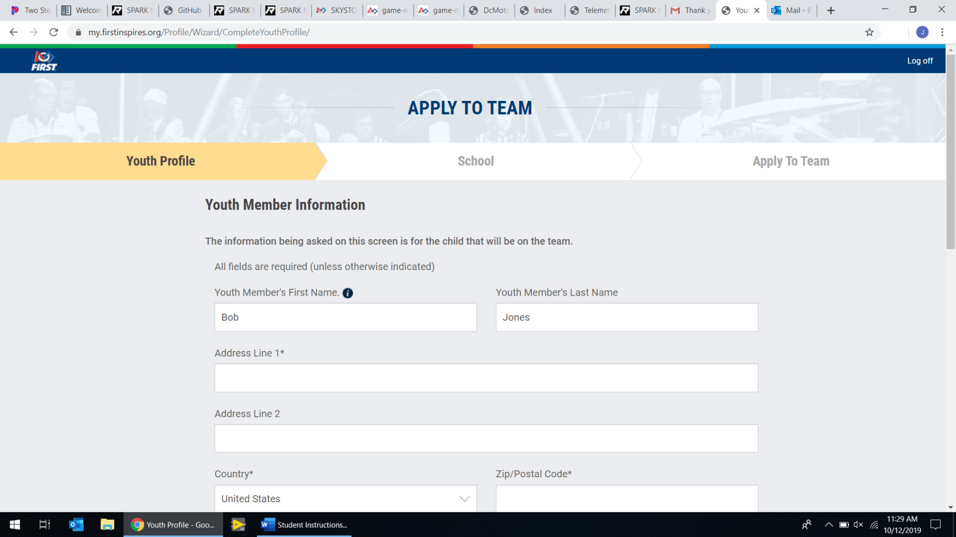

Fill out your information then click “Next”. It will then ask for your school Information. For “School”, click the drop down and find and select your teams school. When all information is entered, click “Next”.

**9**

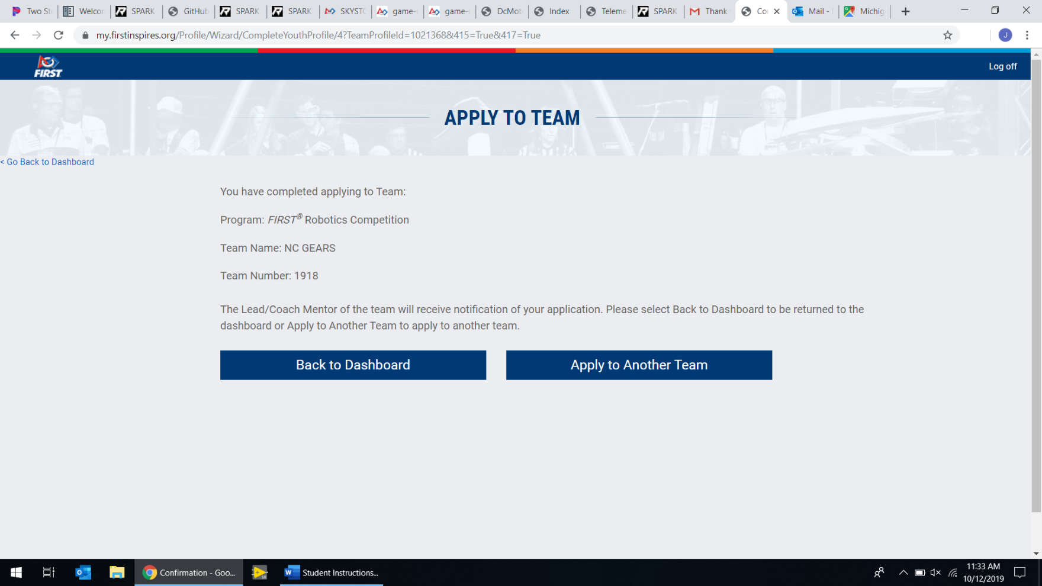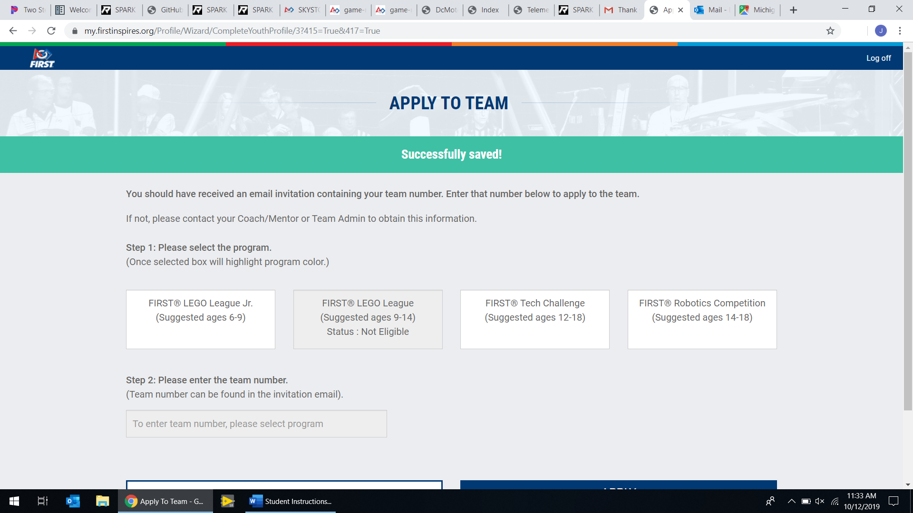

Select “FIRST Robotics Competition (Suggested ages 14-18)” and then enter your teams number in the box asking for team number. Click “Apply”

The next page confirms that you’ve applied; if you got this, you are done. Click “log off” in the top right.

**10**