**Parent FIRST Registration**

**You will need**: Your Email Address

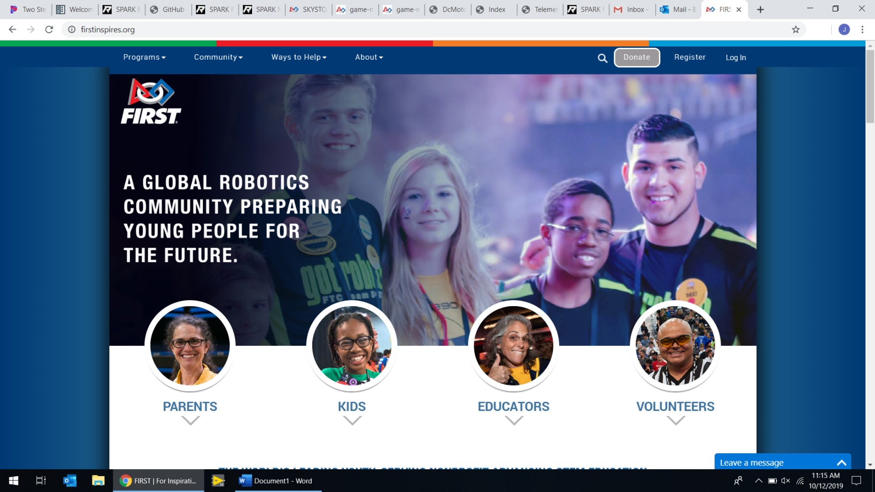

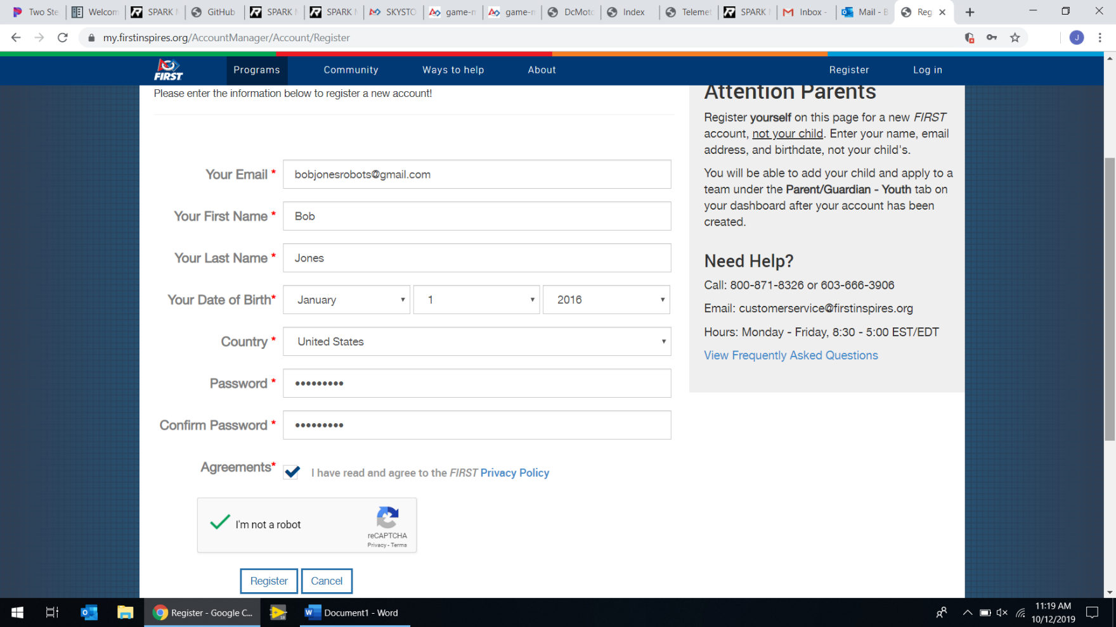

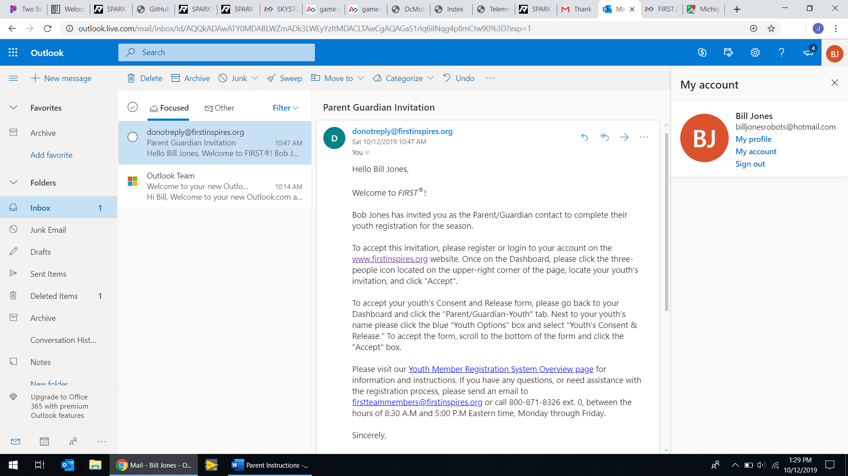

If you have an account, click “Log in” and skip to Step 5. Otherwise, click “Register” in the top right.

**2**

Go to your email and find the Parent Guardian Invitation. Click the link for [www.firstinspires.org](http://www.firstinspires.org).

**1**

Fill in your information and click “Register”. Don’t forget to check the “I’m not a robot” box.

**3**

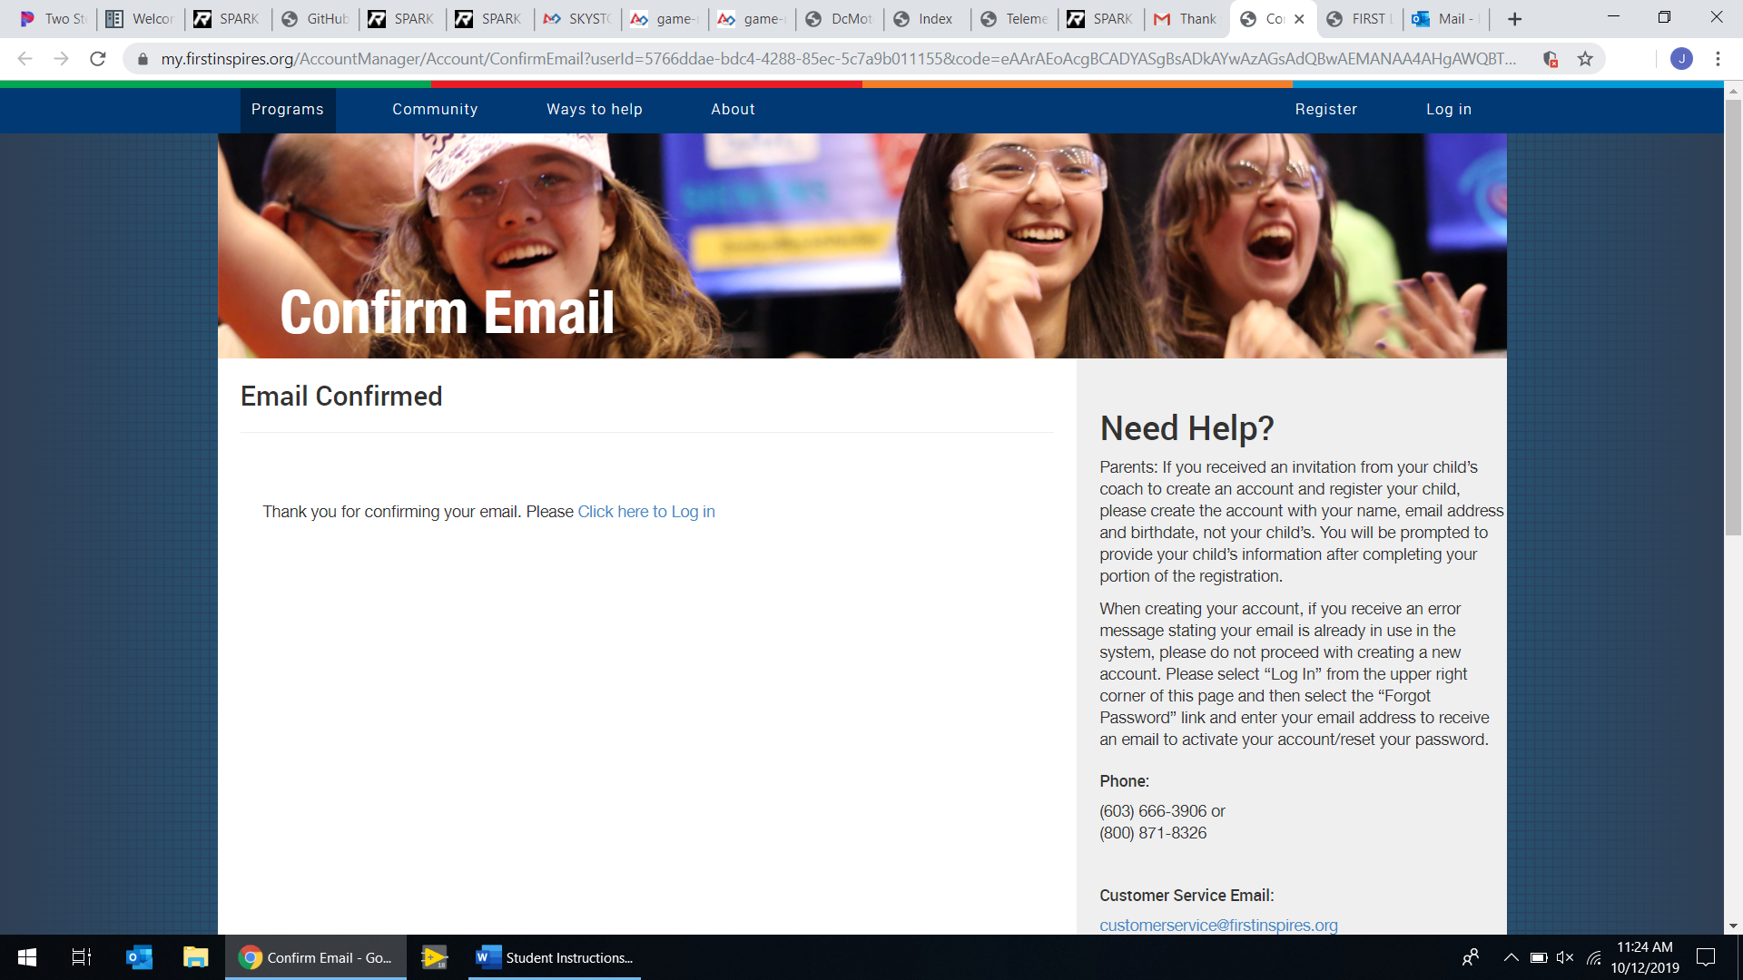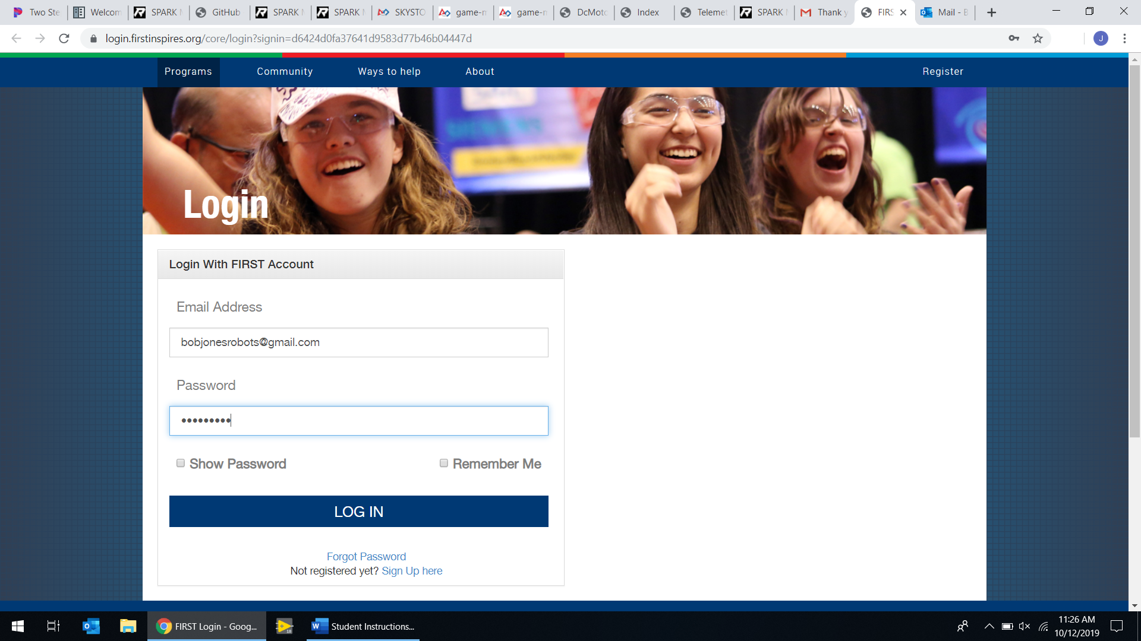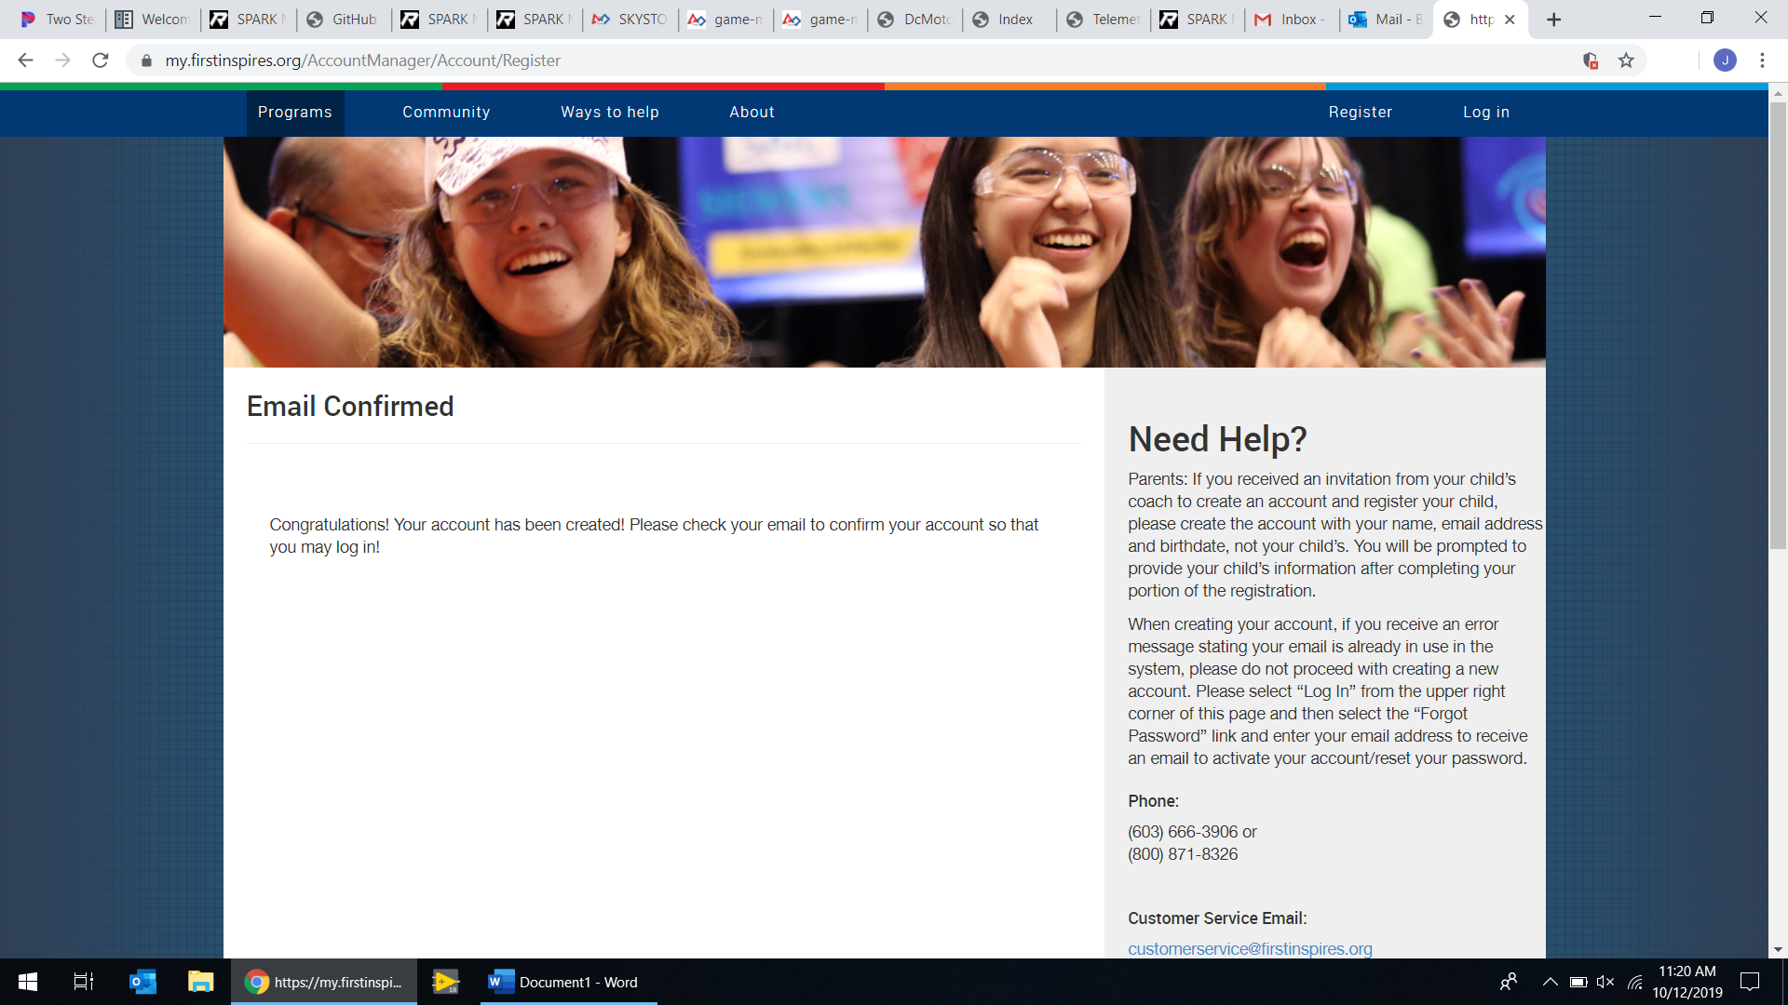

Log in to your account

**5**

Go to your email, find and open the email welcoming you to the FIRST community, and click the link in it to activate your account.

**4**

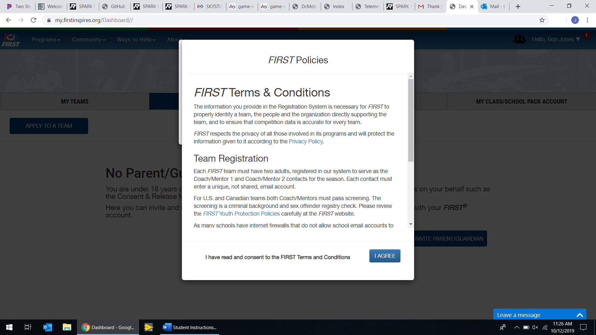

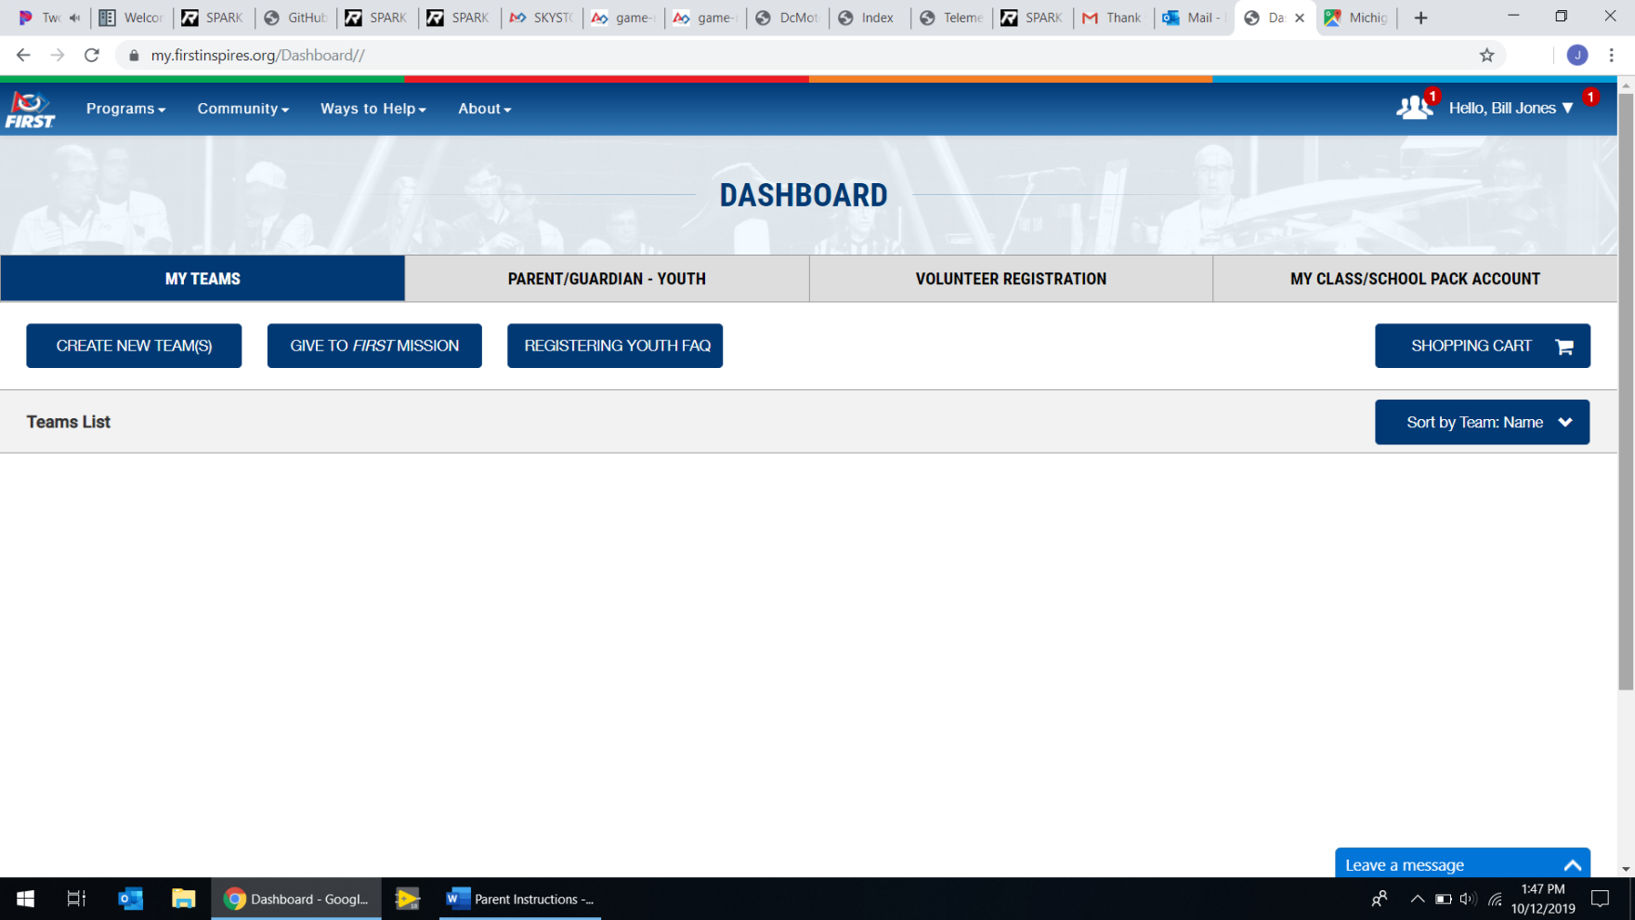

Click the icon in the top right that looks like a group of people.

**7**

Once signed in, a series of pop ups will come up; click “I Agree” on all of them.

**6**

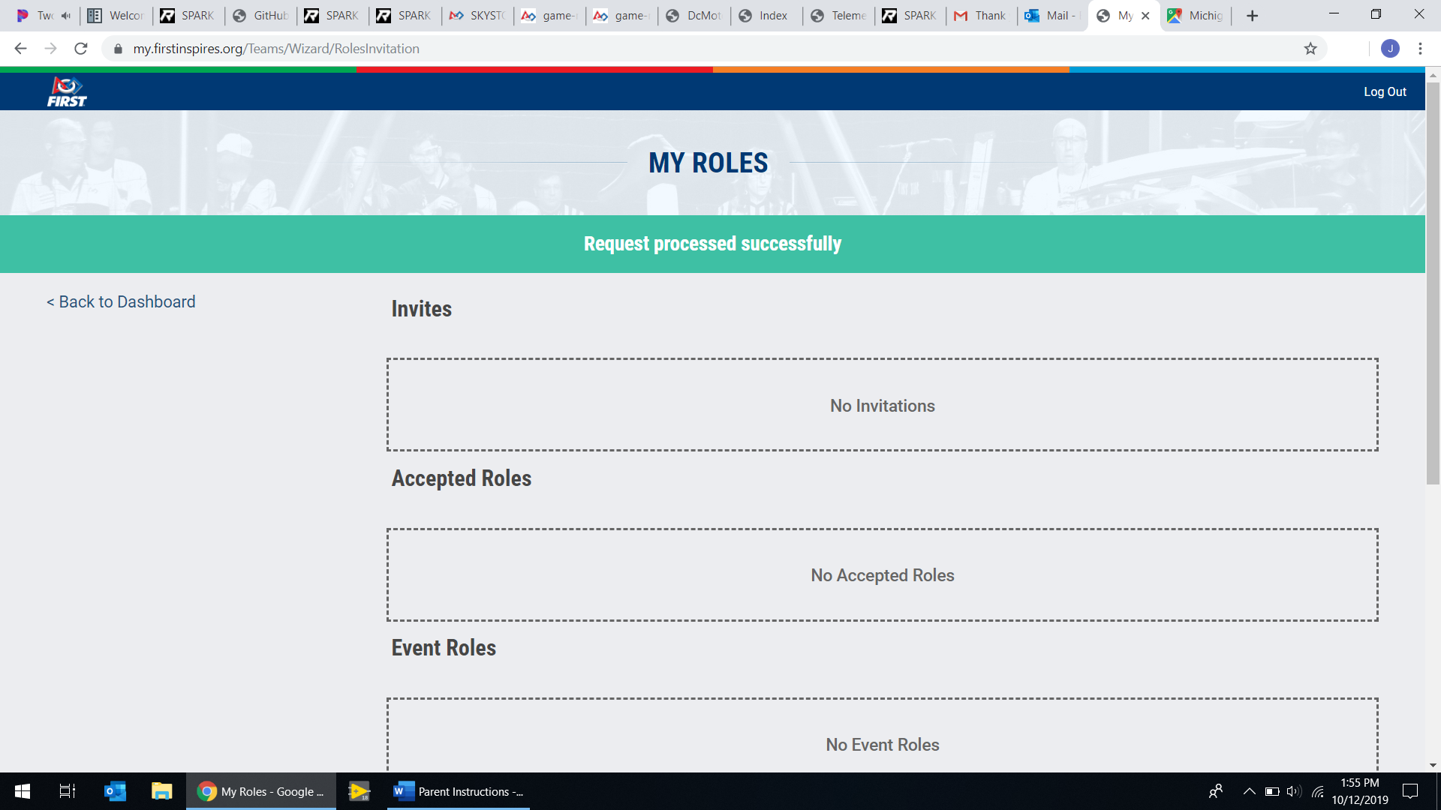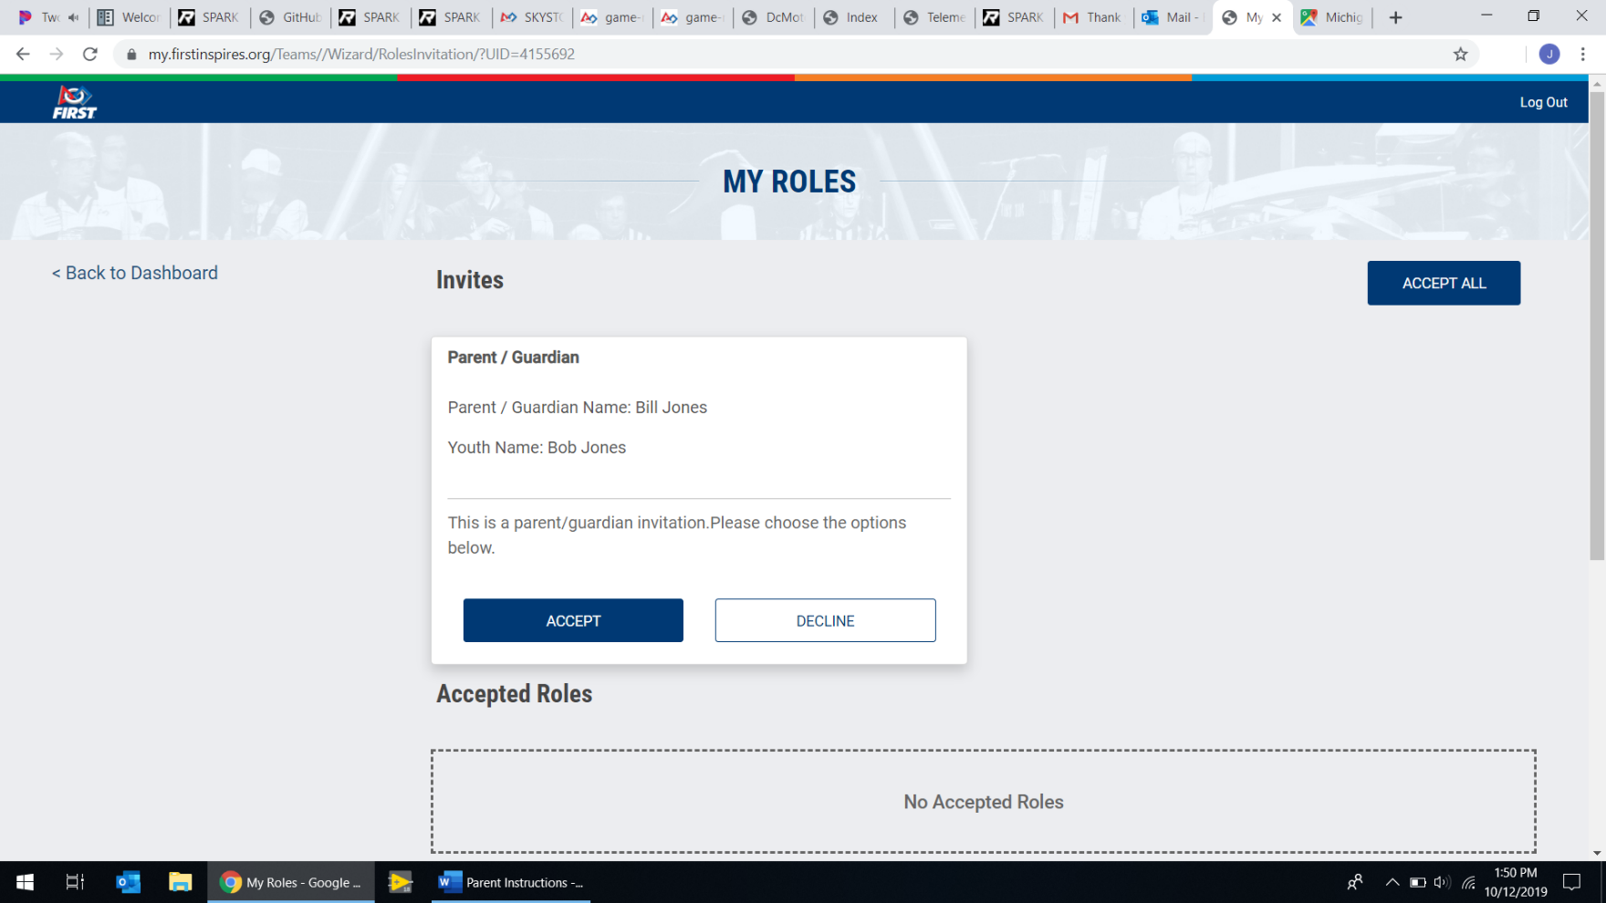

In the “Invites” section, click “Accept”.

**8**

Click “Back to Dashboard”.

**9**

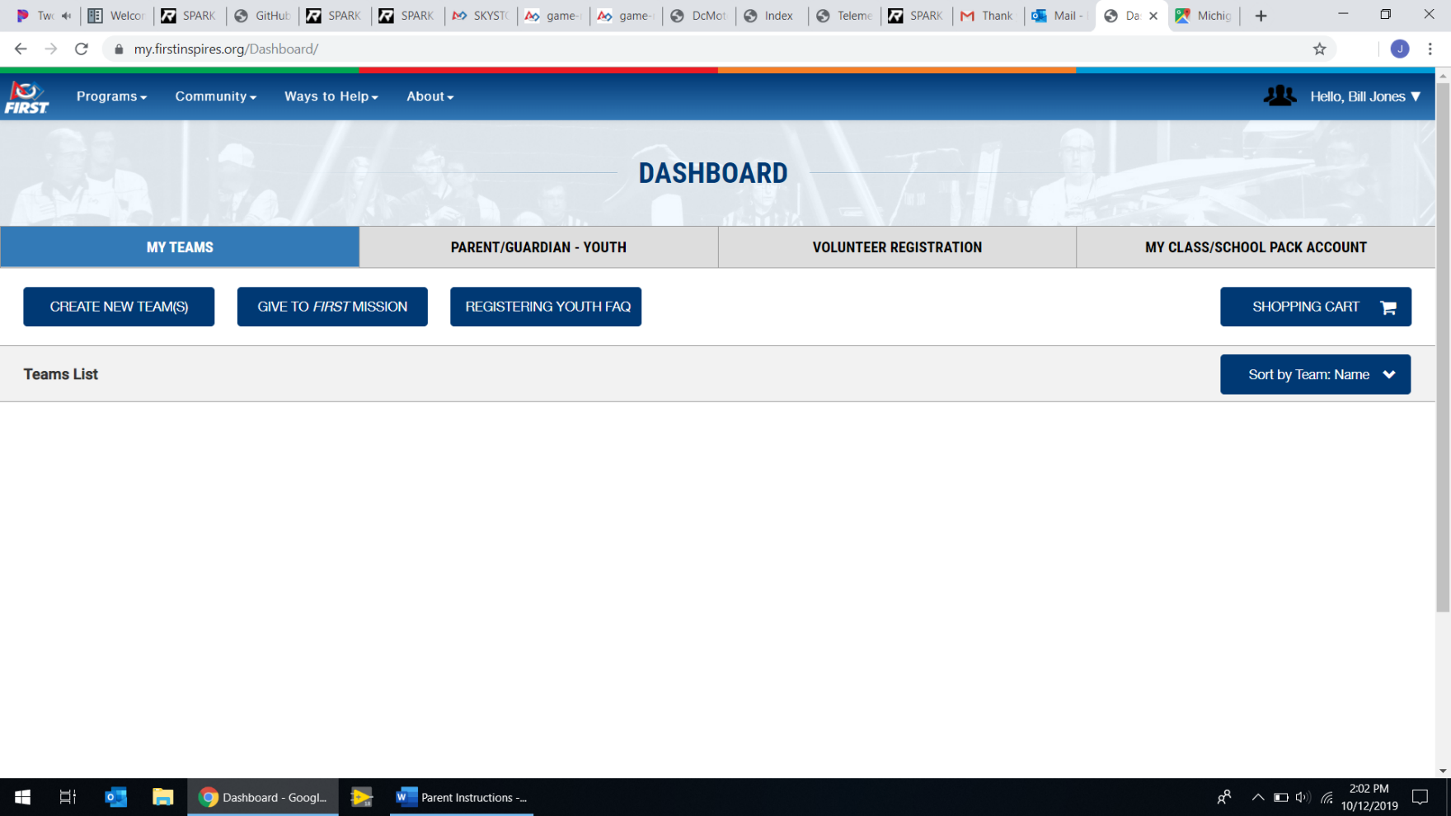

Click “Parent/Guardian - Youth”.

**10**

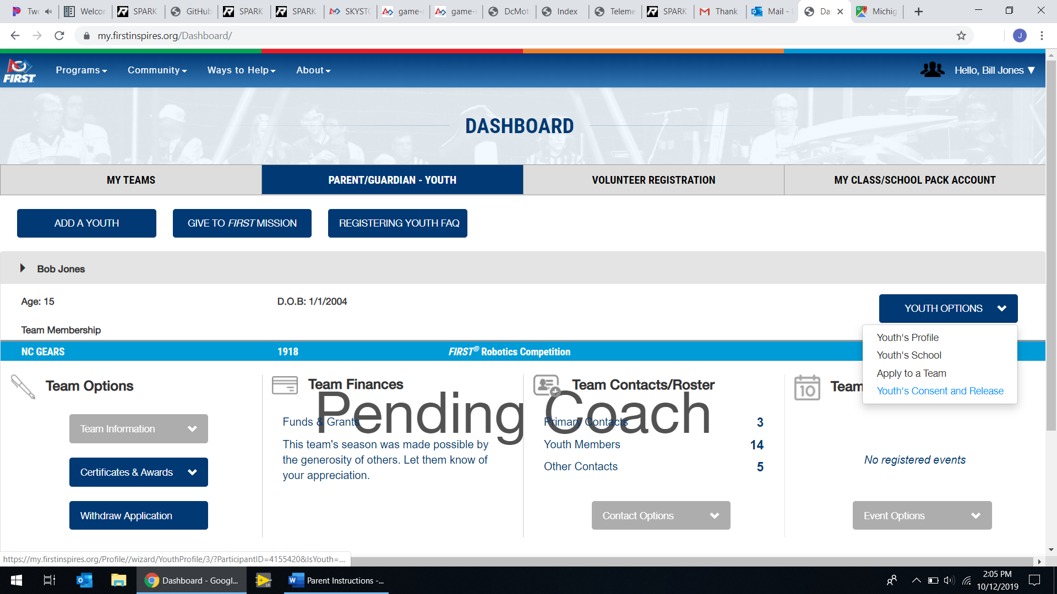

Click “OK” on the pop-up, then click “Youth Options” and then “Youth’s Consent and Release”.

**11**

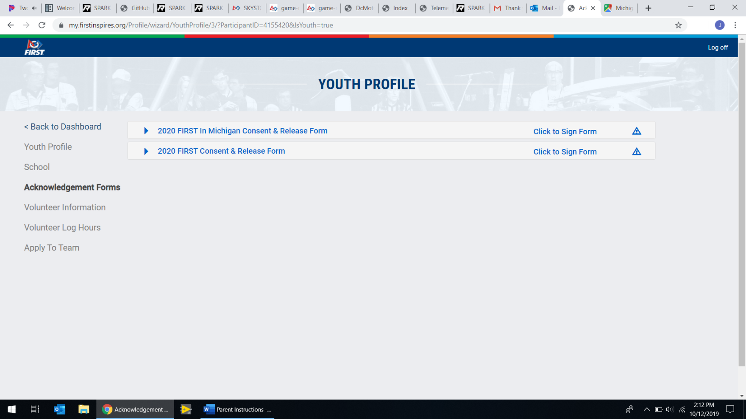

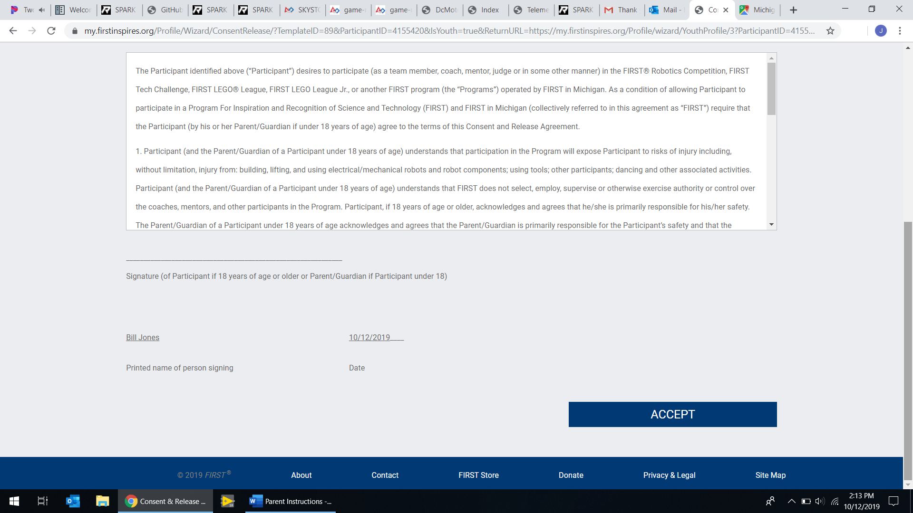

Scroll to the bottom of the page and click “Accept”.

**13**

Click “Click to Sign Form” on the first line.

**12**

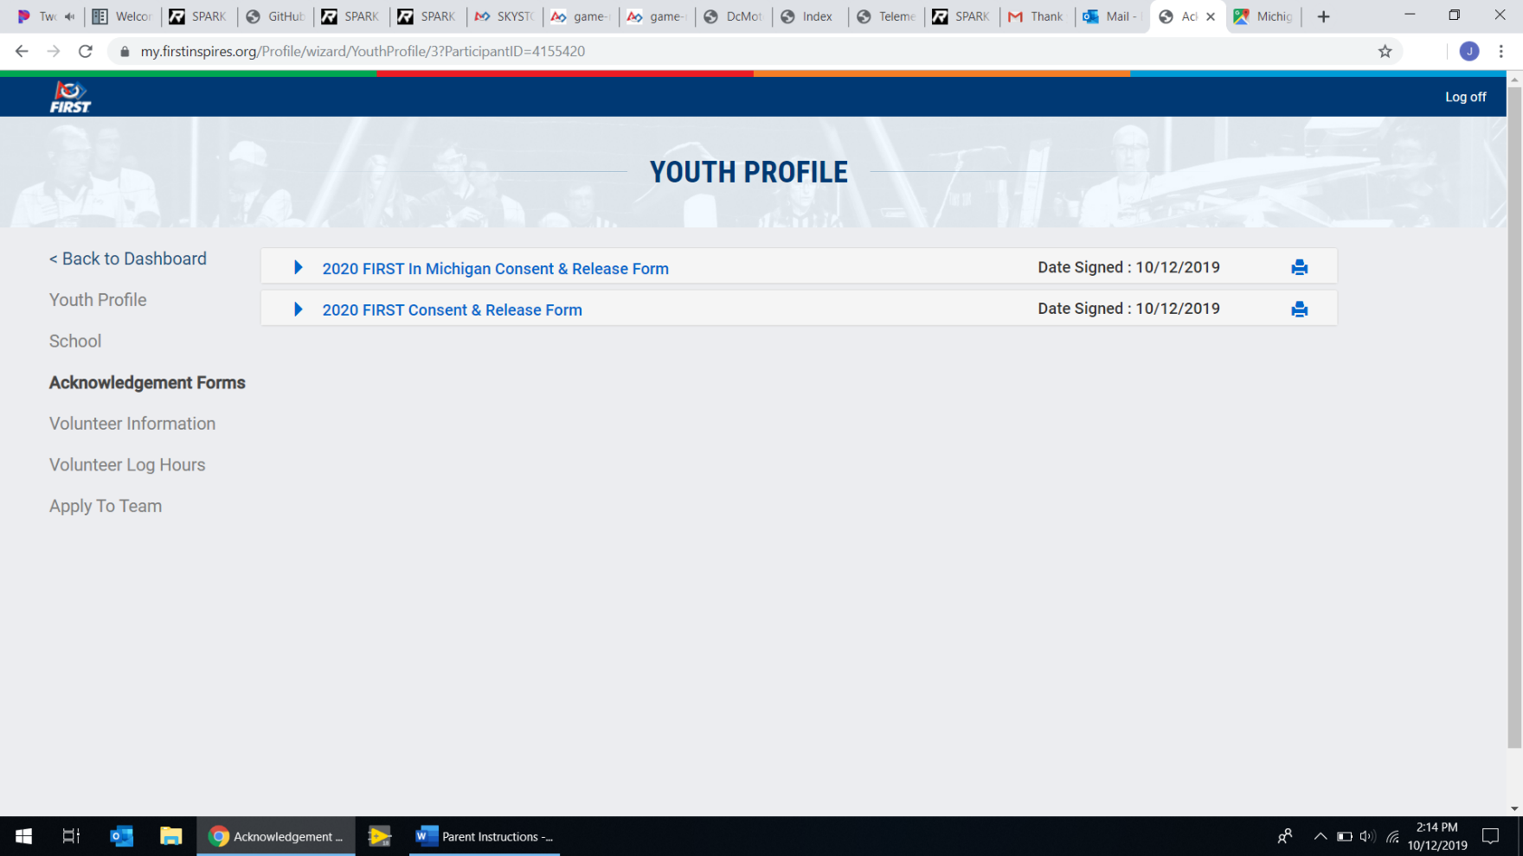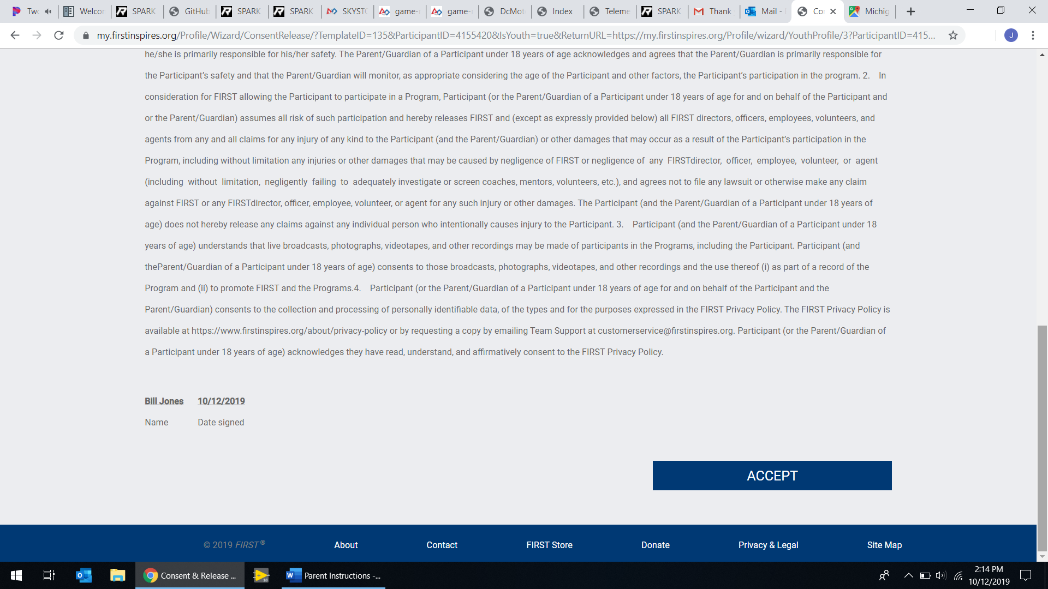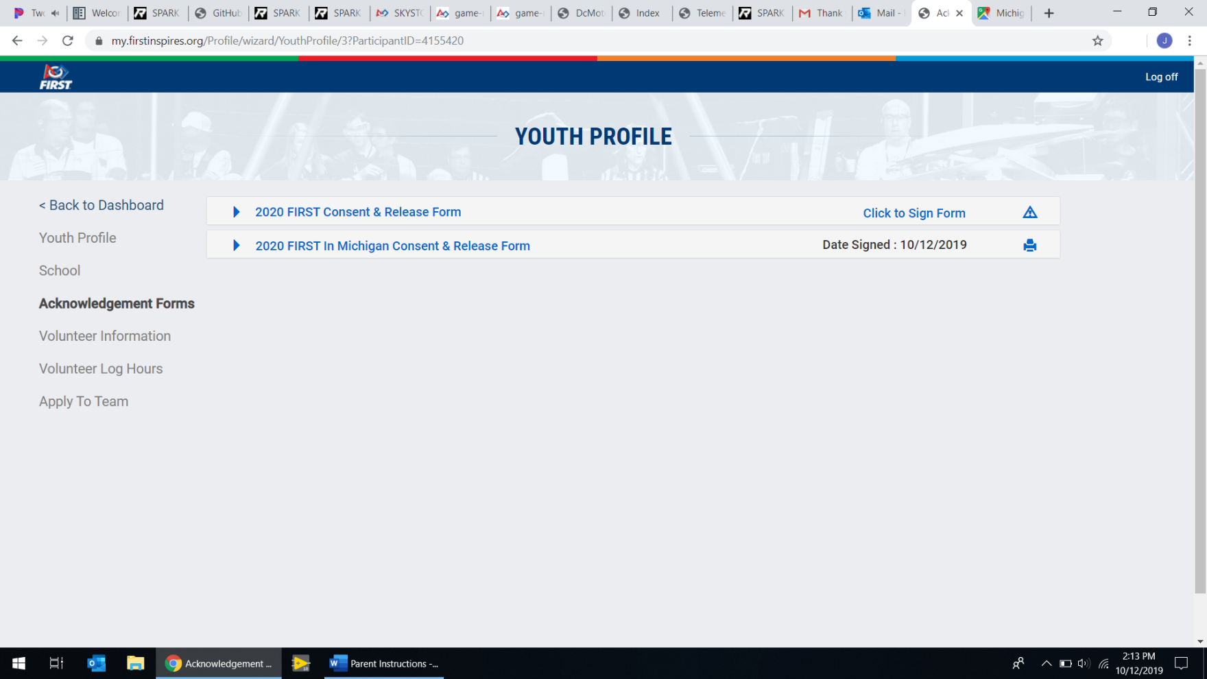

Lastly, click “Log off” in the top right.

**16**

Scroll to the bottom of the page and click “Accept”.

**15**

Click “Click to Sign Form” on the remaining line.

**14**